**Lab No.08**

1. As a programmer, you are required to create a program that takes the first and last name from a user. The program then combines both the inputs taken and prints the string backwards.

#include <stdio.h>

#include<string.h>

int main()

{ **Out put:**

char firstName[20],lastName[20];

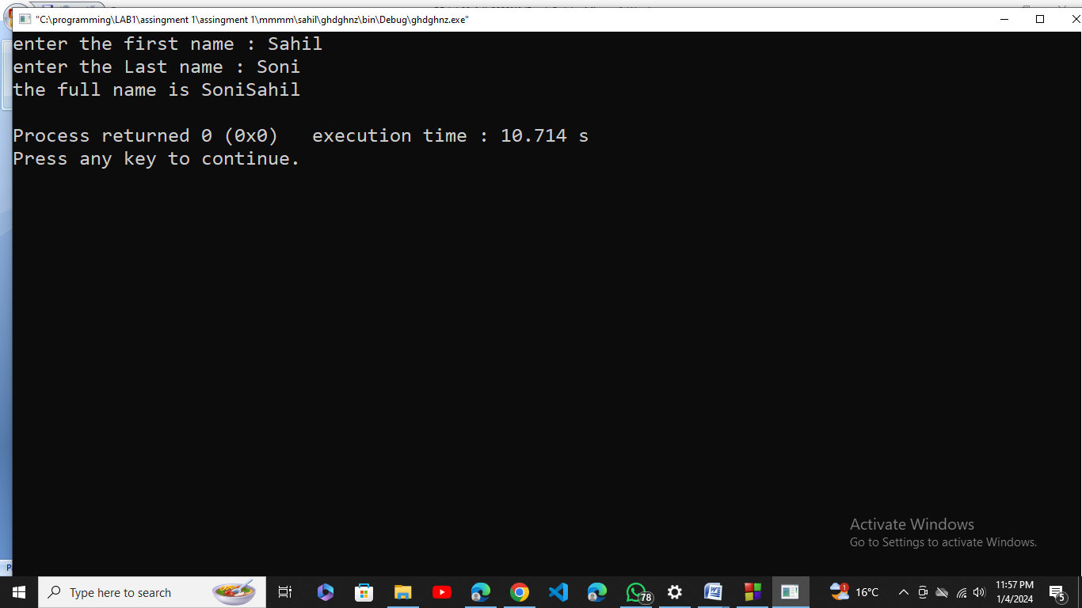

printf("enter the first name : ");

gets(firstName);

printf("enter the Last name : ");

gets(lastName);

strcat(lastName,firstName);

printf("the full name is %s\n",lastName);

return 0;

}

2. Each student is required to find out the maximum frequency of characters occurring in their name and the courses offered in Fall 2021. To find it, the student enters their name, courses offered and the program finds the maximum occurrences of a character in the name and course. Course names should be used like Programming Fundamentals, Applied Physics, Pakistan Studies and so on.

#include <stdio.h>

#include <string.h>

int main()

{

char name[100];

char courses[100];

char str[50];

printf("Enter your name: ");

scanf("%s", name);

printf("Enter your courses: ");

scanf("%s", courses);

int freq[256];

int i, max, ascii; **Out put:**

for (i = 0; i < 256; i++)

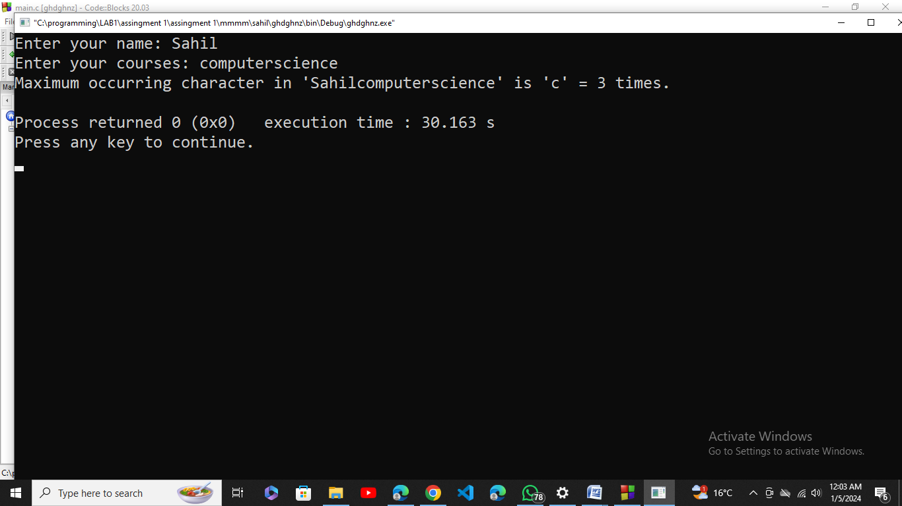

{

freq[i] = 0;

}

strcpy(str, name);

strcat(str, courses);

i = 0;

while (str[i] != '\0')

{

ascii = (int)str[i];

freq[ascii] += 1;

i++;

}

max = 0;

for (i = 0; i < 256; i++)

{

if (freq[i] > freq[max])

max = i; }

printf("Maximum occurring character in '%s' is '%c' = %d times.\n", str, (char)max, freq[max]);

return 0;

}

3. Students are grouped in two to complete a lab task. Each student is required to enter a string of their own choice as an input to the program. The program will then display as a result whether both the strings are equal. If the strings are not equal, the program will display which of the string is greater.

Test cases:

Enter two strings that are same.

Enter two different strings.

**Out put:**

#include <stdio.h>

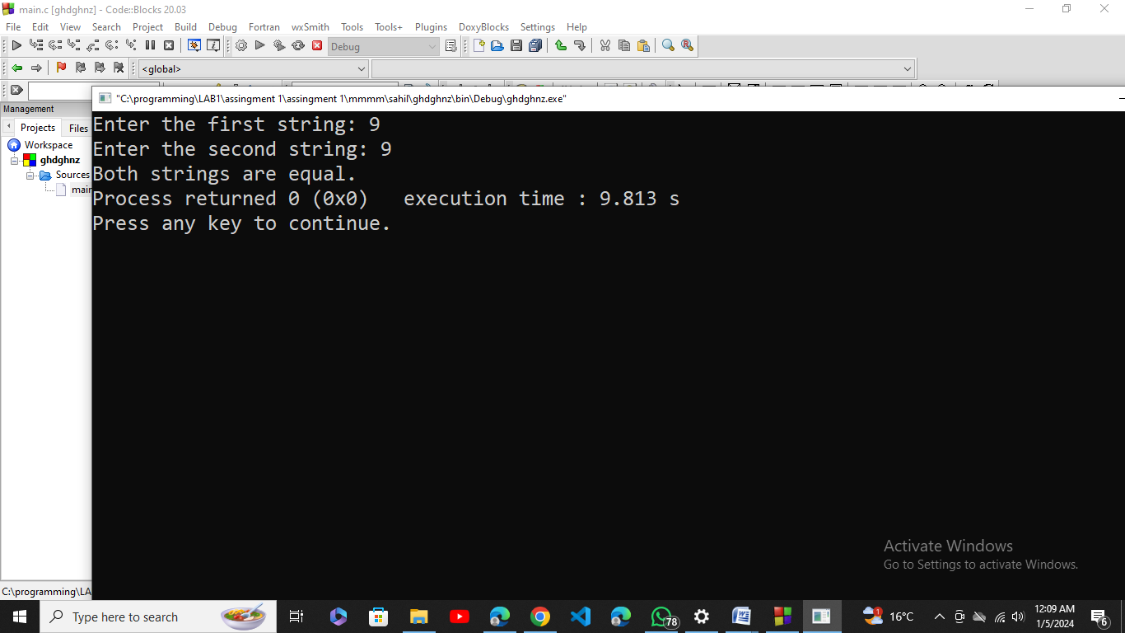

#include <string.h>

int main()

{

char STR[100], STR2[100];

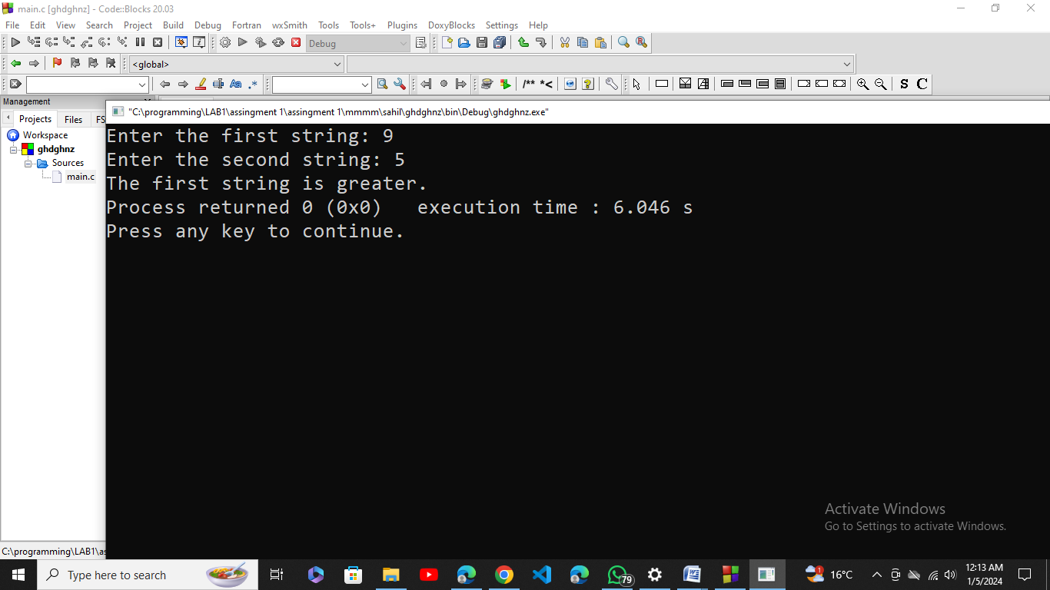

printf("Enter the first string: ");

scanf("%s", STR);

printf("Enter the second string: ");

scanf("%s", STR2);

if (strcmp(STR, STR2) == 0)

printf("Both strings are equal.");

else if (strcmp(STR, STR2) > 0)

printf("The first string is greater.");

else

printf("The second string is greater.");

return 0;

}

**4.** Write down the output of the following program.

int main (void)

{

char a[11] = "hello world";

int i;

for(i = 0; i <= 9; i++)

{

a[i] = a[i + 1];

printf(“%d \t %s \n”, i, a);

}

Printf("\n %d", a);}

CORRECT CODE:

#include <stdio.h>

#include <string.h>

int main (void) **Out put:**

{

char a[11] = "hello world";

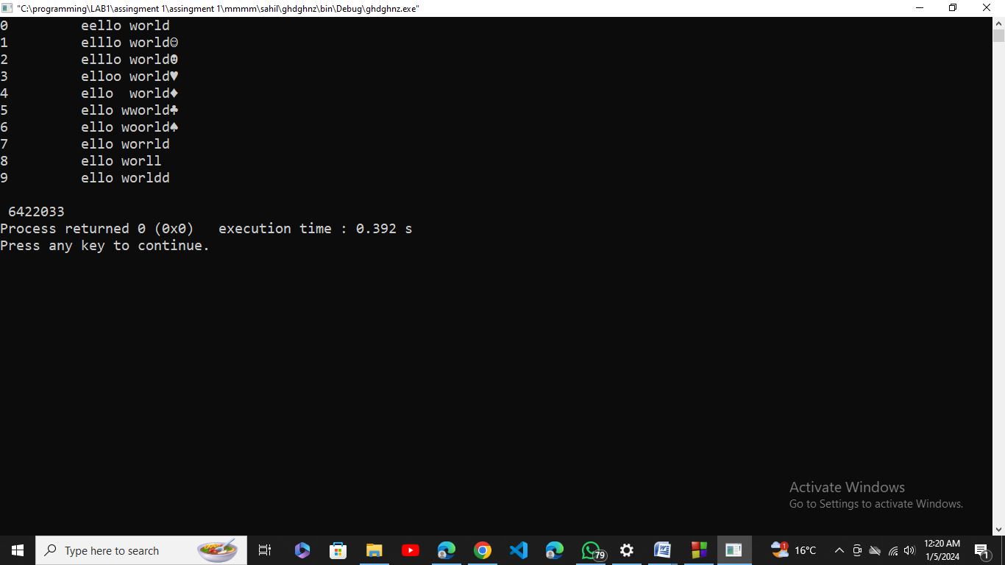

int i;

for(i = 0; i <= 9; i++)

{

a[i] = a[i + 1];

printf("%d \t %s \n", i, a);

}

printf("\n %d", a);

}